Members: Nguyễn An Phúc – 21IT639
Trương Văn Khải – 21IT417
Trần Vũ Lập Thi – 21IT448
Nguyễn Hữu Khánh – 21IT083

Git Tutorial for beginne
- Step 1: Create a local git repository
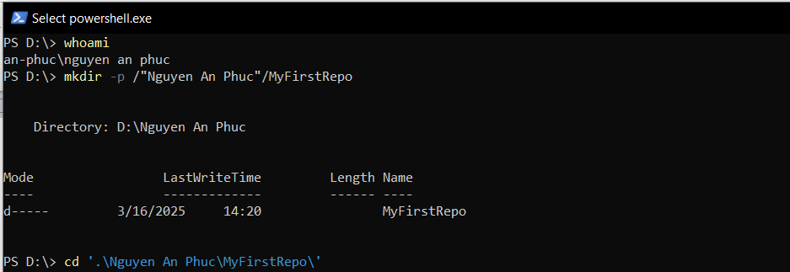
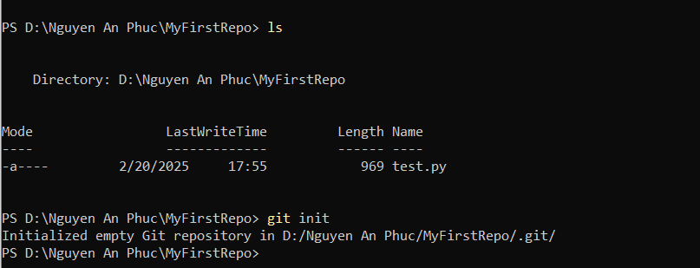
- STEP 2: Add a new file to the repo
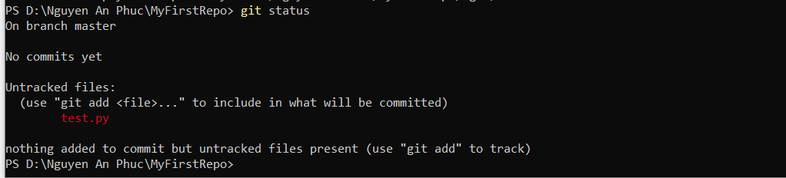
- STEP 3: Add a file to the staging environment
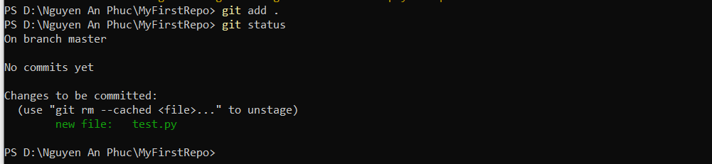
- STEP 4: Create a commit
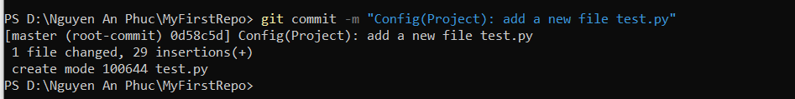
- STEP 5: Create a new branch
- Step 6: Create a new repository on GitHub
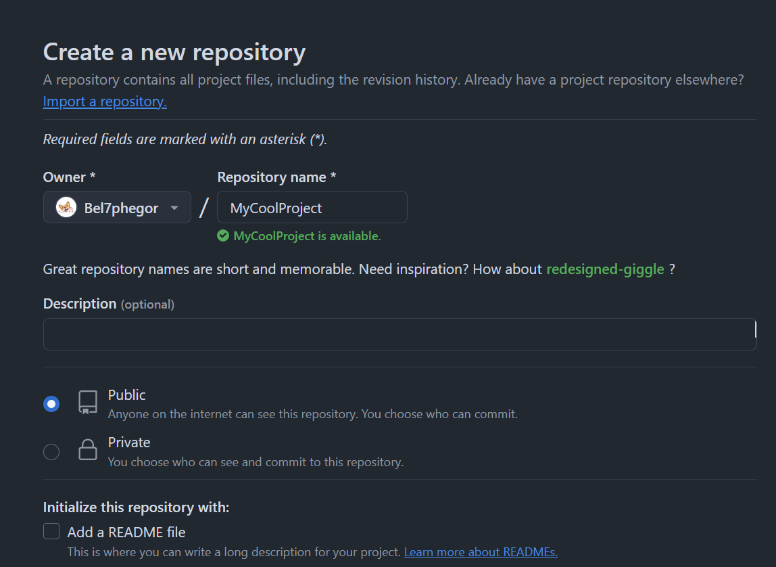
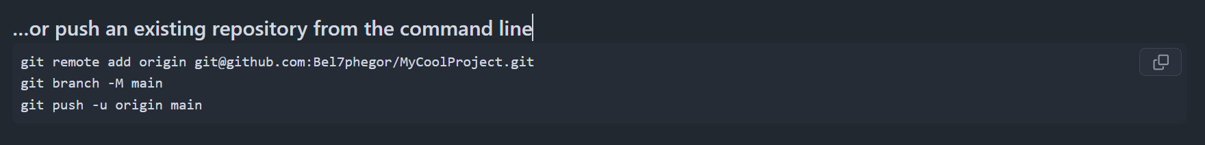
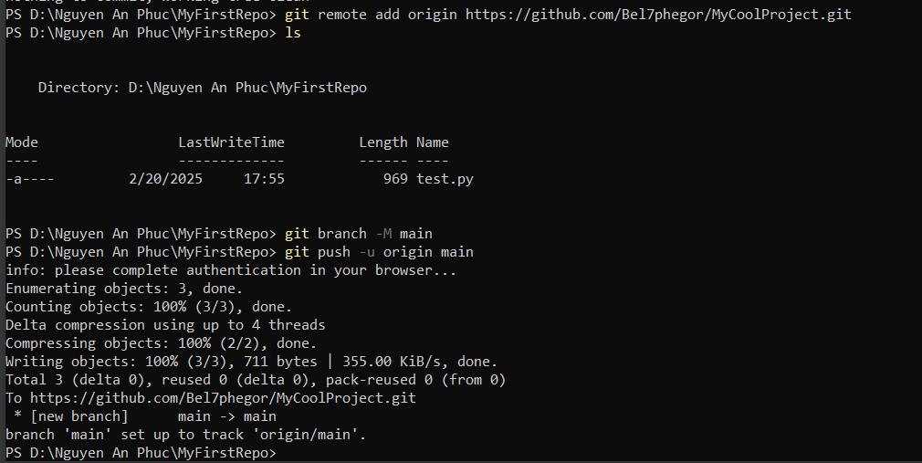
- Step 7: Push a branch to GitHub
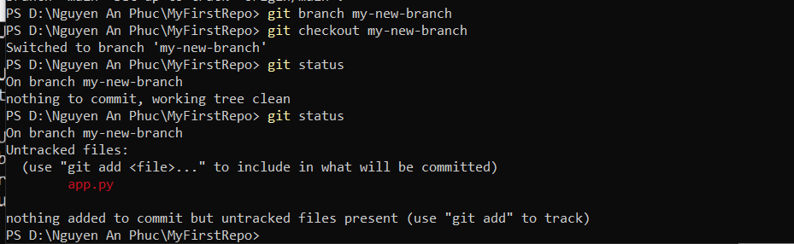
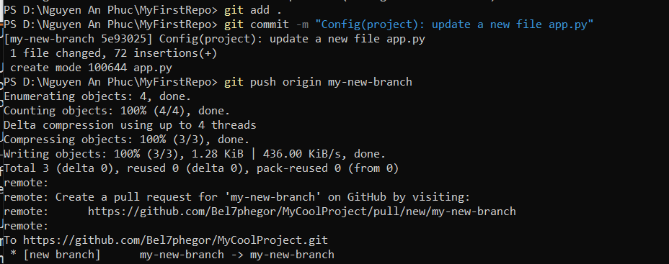
In github:
Main branch
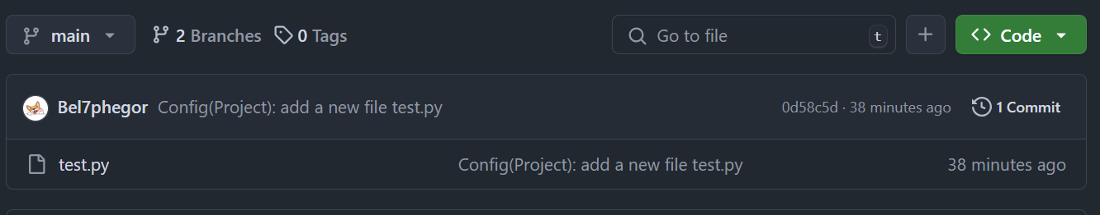
My-new-branch
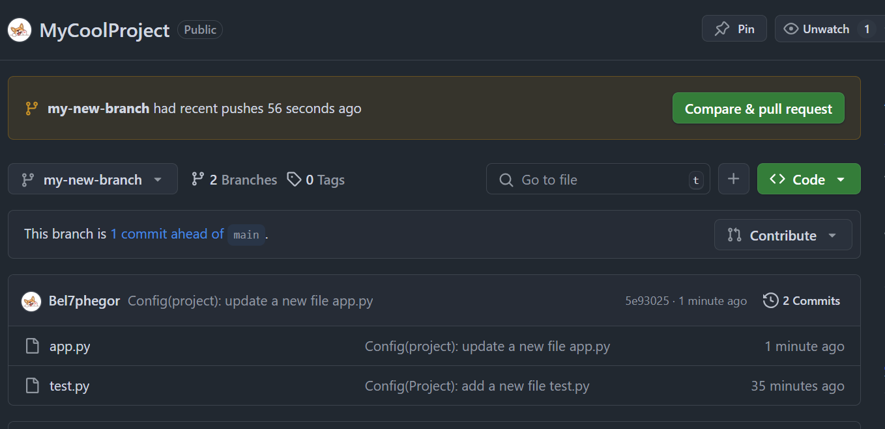
- Step 8: Create a pull request (PR)
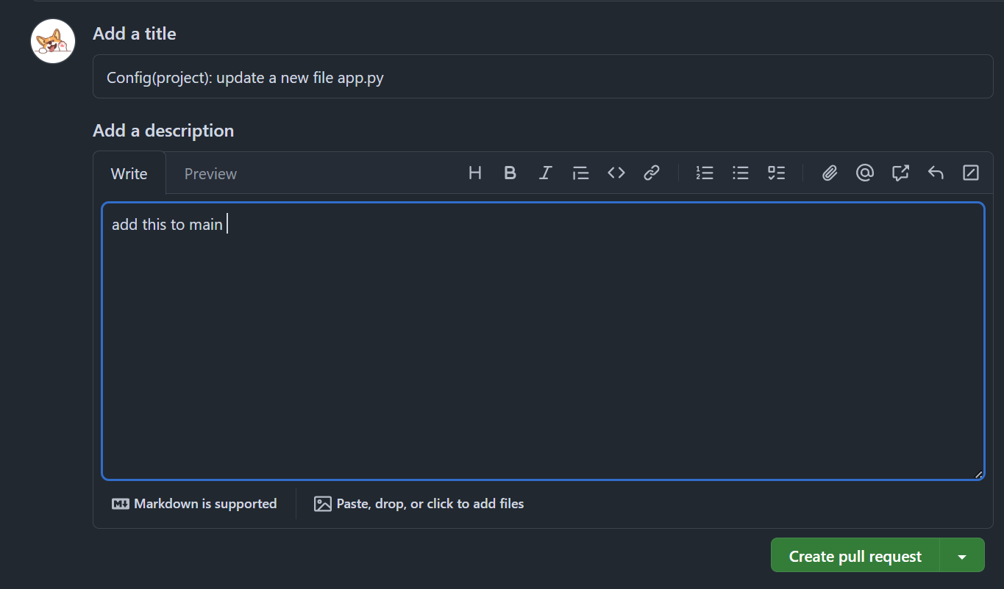
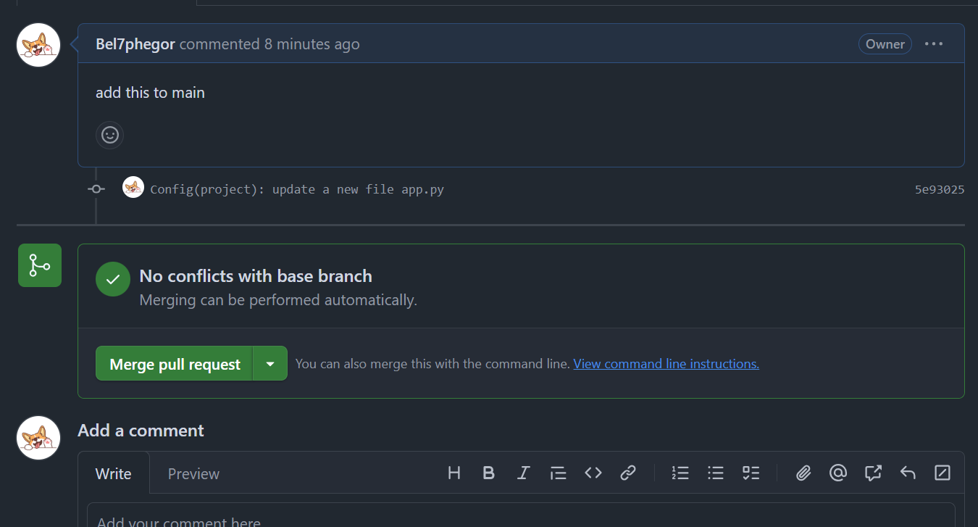
- Step 9: Merge a PR
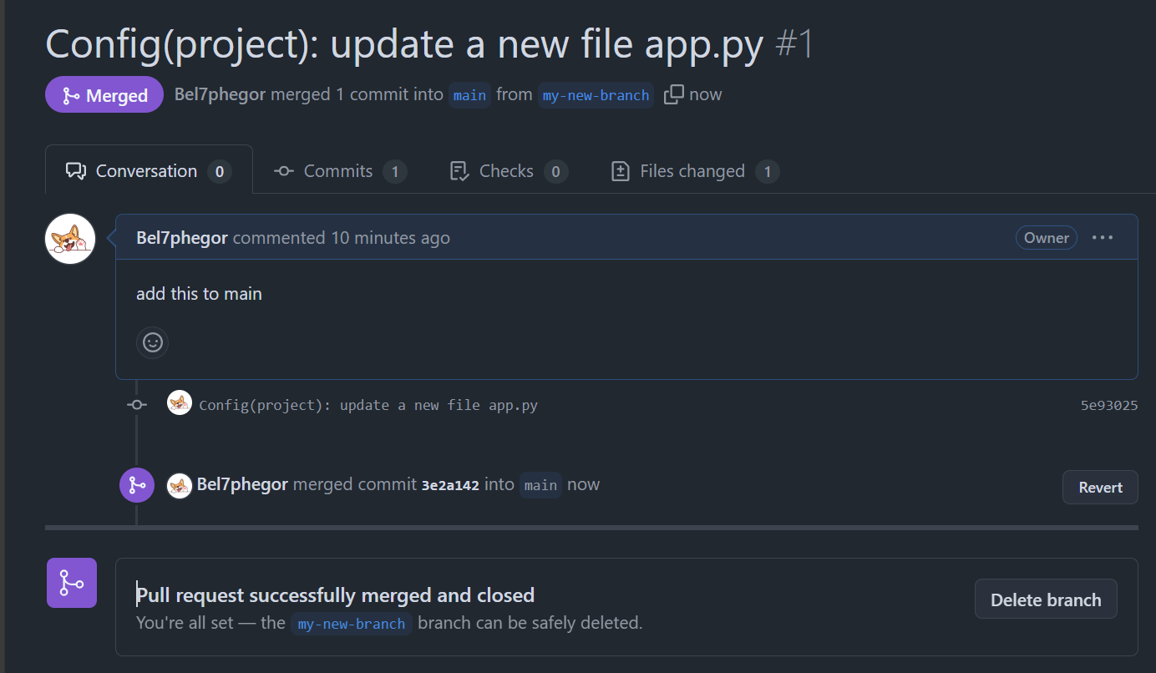
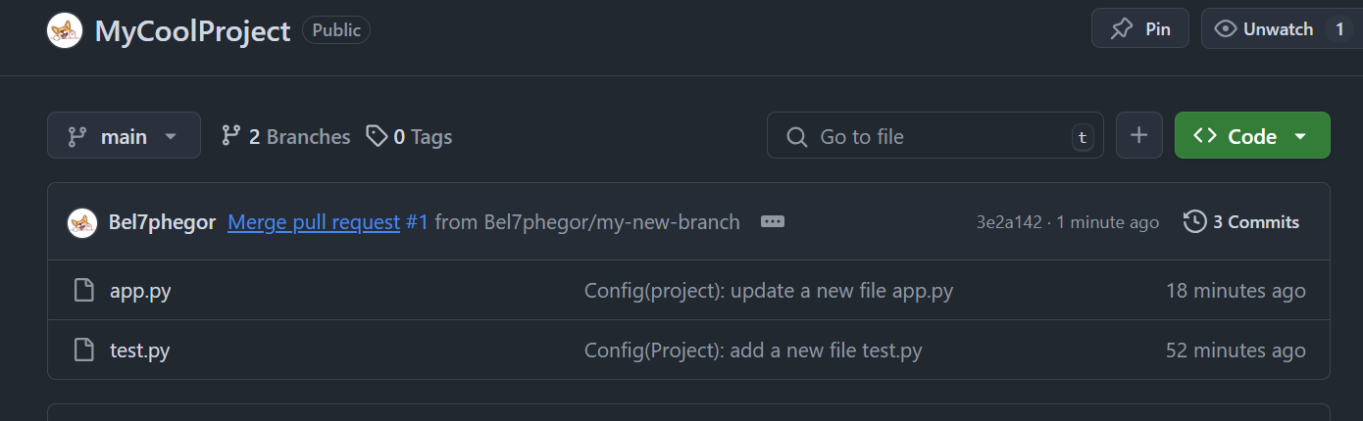
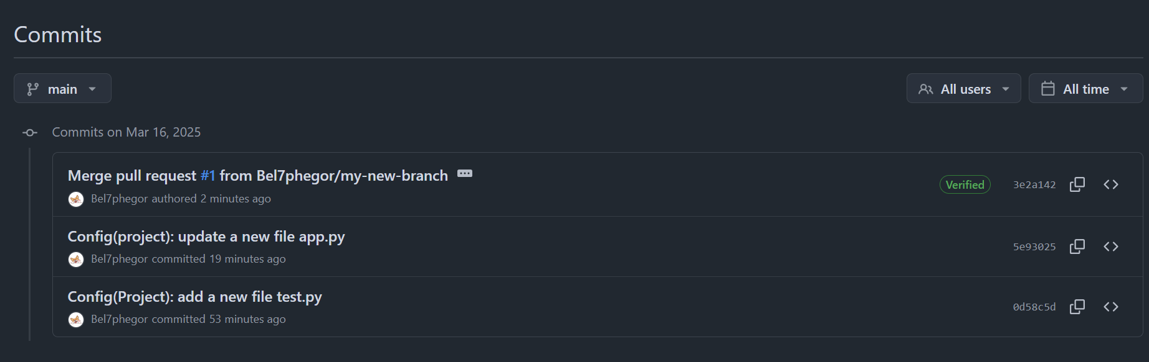
- Step 10: Get changes on GitHub back to your computer
